Bhakti- Sufi Traditions
- ------------may not be literally accurate, but allow a glimpse into the ways in which devotees perceived the lives of saintly persons.
- Chronicles
- Puranas
- Hagiographies
- Biographies
Ans. C. Hagiographies
- Identify the picture of a devotee of Shiva who composed beautiful devotional songs in Tamil

- Manikkavachakar
- Karaikkal Ammaiyar
- Andal
- Mahavir Vardhaman
Ans. A. Manikkavachakar
- Who preaches Vishisthadvaita?
- Saivaite Nayanmars
- Tulsidas
- Adiguru Shankaracharya
- Ramanuja
Ans. D. Ramanuja
- Where was Kabir born ?
- Allahabad
- Varanasi
- Gorakhpur
- Mathura
Ans. B. Varanasi
- What was the other name of Virashaivas?
- Nayanaras
- Alvars
- Lingayats
- Panchacharyas
Ans. C. Lingayats
- What do you mean by Tevaram?
Ans. Tevarams are collection of compiled and classified in the 10th century on the basis of the music of the songs of Appar, Sambandar, and Sundarar.
- For whom did Akbar commission the construction of a white marble at Fatehpur Sikri, which was just next to Friday Mosque?
- Shaikh Nizamuddin Auliya
- Shaikh Nasiruddin
- Shaikh Salim Chisti
- Shaikh Muinuddin Chisti
Ans. C. Shaikh Salim Chisti
- Kabir’s Poem are written in a form in which everyday meanings are inverted. With what name is it known?
- Guru bani
- Sant Bhasha
- Ulatbansi
- None of these
Ans. C. Ulatbansi
- The tax imposed by the Muslim rulers on non-Muslim subjects for giving protection was called what?
- Kharaj
- Zakat
- Jizya
- None of the above
Ans. C. Jizya
- Consider the following statements regarding Tantric practices:
- were widespread in several parts of the subcontinent
- they were open to women and men, and
- practitioners often ignored differences of caste and class within the ritual context.
- Many of these ideas influenced Shaivism as well as Buddhism
Which of the above are correct reasons for Tantricism?
- 1 and 4
- 2 and 3
- 2 and 4
- 1, 2, 3 and 4
Ans. D. 1, 2, 3 and 4
- Which sacred composition of Alvars was frequently described as the Tamil Veda?
Ans. Nalayiradivyapravandhan of Alvars was frequently described as the Tamil Veda.
- What are Vachanas?
- Vachanas are a prosaic form very much popular in the Kannada literature. It propagates
values of universal brotherhood.
- Basavanna used Vachana form of writing style to spread social awareness and bring equality in the 12th-century society.
- Vachanas conveyed complex concepts in simple form by using day-to-day life experiences, similes, images, symbols and metaphores.
- Vachanas are used as the means to purify one in word, action, and vision.
Which of the above statement is/are correct?
- 1 and 4
- 2 and 3
- 2 and 4
- 1, 2, 3 and 4
Ans. D. 1, 2, 3 and 4
- Why do people visit Darghas?
- People visit the Shrine when they or a loved one are sick.
- They visit it to seek advice from the Pir
- Indians of all faiths feel culturally Connected
- paying their respects to deceased pious individuals
Which of the above statement is/are correct?
A. 1 and 4
B. 2 and 3
C. 1,3 and 4
D. 1, 2, and 4
Ans. C. 1,3 and 4
- The European traveller who has given a detailed description of the practice of Sati.
- Jean Baptiste Tavernier
- Manucci
- Francois Bernier
- Roberto Nobili
Ans. C. Francois Bernier
- Identify which of the following aspects is NOT common to both Bhakti movement and Sufi movement?
- Personal love for God
- Worship of idols
- Mysticism
- Visit to holy shrines
Ans. B. Worship of idols
- Consider the following statement
- The songs compilations of Nayanars are tevaram and tiruvakam
- Andal is a famous woman Nayanar saint
Which of the above statements is/are correct?
- Only 1
- Only 2
- Both 1 and 2
- Neither 1 nor 2
Ans. A. Only 1
- Which of the following statements is/are correct ?
- Sikhism has influences of bhakti tradition
- It is a syncretic religion
- Guru Arjan gave it a militaristic outlook
- Only 1
- Only 2 and 3
- Only 1 and 2
- 1,2 and 3
Ans. C. Only 1 and 2
- Jagannatha temple at Puri is a pilgrimage centre today. Which of the following is/are correct about it?
- It is a based on Vaishnavite cult
- The deity has a tribal inspiration
- The temple was built by King Anangabhima III
Select the correct answer using the code below.
- Only 1
- Only 2 and 3
- Only 1 and 2
- 1,2 and 3
Ans. C. Only 1 and 2
- Which of the following is /are correct about Jiziya?
- Jiziya was not a separate tax since beginning under Muslim rule
- At times Brahmins were exempted from paying Jiziya
- Firoz Tughlaq made it a part of Land Tax
Select the correct answers using the codes below
- Only 1 and 2
- Only 2
- Only 2 and 3
- Only 1
Ans. A. Only 1 and 2
- Which of the following is NOT correct about Vishistadvaita philosophy propounded by Ramanujacharya ?
- God is a Saguna brahman
- Self-surrender to God is the way to achieve him
- Soul and matter are not Real
- His philosophy was rooted in Vaishnavism
Ans. C. Soul and matter are not Real
- Tevaram – a collection of compiled and classified in the 10th century on the basis of the music of the songs of ----------
- Appar
- Sambandar
- Sundarar
- All of the above
Ans. D. All of the above

- Identify the sculpture of the Buddhist goddess (Ray of Light), an example of the process of integration of different religious beliefs and practices. She is a multi-armed woman with a different weapon in each hand standing or sitting on the back of a boar and as having three faces and six or eight arms.
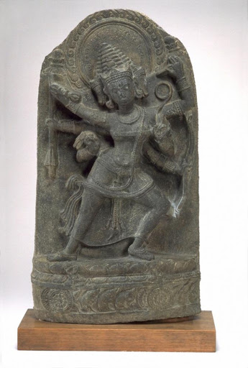
- Maya Devi
- Marichi
- Kurukulla
- Ugra Tara
Ans. B. Marichi
- Which ascetics of the yoga school of Hindu philosophy influenced Ramananda?
- Kabirpanthis
- Krishna cult
- Nathpanthis
- None of these
Ans. C. Nathpanthis
- Different Sufi schools or orders in India were known as------
- Khanqah
- Ziyarat
- Urs
- Silsilah
Ans. D. Silsilah
- The earliest Sufi order to arrive in India was--------
- Qadri
- Chisthi
- Shurawadi
- Naqsbandi
Ans. B. Chisthi
- Select the correct statement related to Bhakti movement in medieval history.
- To the theistic devotional trend that emerged in medieval Hinduism and later revolutionised in Buddhism.
- It refers to trend that emerged in medieval Hinduism and later revolutionised in Jainism.
- To the theistic devotional trend that emerged in medieval Hinduism and later revolutionised in Sikhism.
- None of the above
Ans: C
- What the term bhakti refers to:
- Bhakti is derived from root bhaj, meaning ‘divide’
- Bhakti is derived from root bhaj meaning ‘possess’
- Both A & B
- Only B
Ans : C
- Who was the leader of the Hindu revivalist movement ?
- Chaitainya Mahaprabhu
- Ramananda
- Ramanuja
- Shankracharya
Ans : D
- Who are jangamas ?
- Religious head of lingayats
- Priest of Shiva temple
- The most reveres linagayats (wandering monks)
- They are the superiors who imparts knowledge
Ans. C
- Assertion (A) : Lingayats supported post puberty marriage.
Reason (R) : Scientifically it benefits the women.
- A is true but R is not the correct explanation of A
- A is false and R is true
- A is true and R is true
- Both A and R are true. R is the correct explanation of A
Ans. D
- Who is known as the confronter of poor
- Shaikh Salim Chisthi
- Khwaja Muinuddin Chisthi
- Amir Khusrau
- Shaikh Nizamuddin Auliya
Ans. B
- Who wrote Munis Al Arwah
- Quli Khan
- Jahanara
- Jahangir
- None of the above
Ans. B
- Find the pair that is not correctly matched
- Pilgrimage - Ziyarat
- Khanqahs – dargah
- Sheikh- wali
- Disciple- murids
Ans. B
- Shaikh Nizamuddin Auliya was disciple of which Sufi Saint?
- Baba Farid
- Khwaja Moinuddin Chisti
- Sheikh Nasiruddin Mahmud
- Sheikh Shihabuddin
Ans. A
- Which of the following Sufi order regarded money as a carrion?
- Suharwardi Order
- Chisti Order
- Quadaria
- Firdausi
Ans. B
- What was the popular title of Sheikh Nizamuddin?
- Mahboob-i-Illahi(the beloved of the God)
- Taufiq-i-illahi
- Chirag-i-Delhi
- Chirag-i- Sabar
Ans. A
- The term Sufi derived from Arabic word Safa which means?
- One who are from Arab and wear woolen cloths
- One who wear woollen clothes and symbolises purity and sacredness
- One who wear saffron colour cloth (Darwesh)
- All of the above
Ans. B
- What is the meaning of 'Tasawwuf'?
- Priesthood
- Islamism
- Sufism
- Humanism
Ans. C
- Which of the following Sufi order claimed direct contact to the God?
- Mahadawi
- Qalandaria
- Risi
- Shattari
Ans. D
- Who among the following was born into a Rathore royal family of Kudki district of Pali, Rajasthan and was a 16th-century Hindu mystic poet and devotee of A. Krishna?
- Ramananda
- Mirabai
- Tukaram
- Kabir
Ans. B
- Consider the following statements regarding the early traditions of Bhakti:
I.In the course of the evolution of forms of worship, in many instances, poet-saints emerged as leaders around whom there developed a community of devotees.
II. Brahmanas remained important intermediaries between gods and devotees in several forms of bhakti.
III. At a different level, historians of religion often classify bhakti traditions into two broad categories: saguna (with attributes) and nirguna (without attributes).
Which of the following statement(s) is/are correct?
- Only I
- I and II
- I and III
- All of the above
Ans. D
- Consider the following statements about Alvars and Nayanars:
- Some of the earliest bhakti movements (c. sixth century) were led by the Alvars (literally, those who are “immersed” in devotion to Vishnu) and Nayanars (literally, leaders who were devotees of Shiva).
- They travelled from place to place singing hymns in Tamil in praise of their gods.
- During their travels the Alvars and Nayanars identified certain shrines as abodes of their chosen deities.
Which of the following statement(s) is/are correct?
- Only I
- I and II
- I and III
- All of the above
Ans. D
- Consider the following statements regarding the attitudes of Alvars and Nayanars towards caste system:
- Alvars and Nayanars initiated a movement of protest against the caste system and the dominance of Brahmanas or at least attempted to reform the system.
- Alvars and Nayanars always supported the caste system in the society.
- The importance of the traditions of the Alvars and Nayanars was sometimes indicated by the claim that their compositions were as important as the Vedas.
Which of the following statement(s) is/are correct?
- Only I
- I and II
- I and III
- All of the above
Ans. C
- Which of the following statements is incorrect about Andal?
- Andal was a woman Alvar, the most striking features of her compositions were widely sung (and continue to be sung to date).
- Andal was a woman Nayanar, she incorporated the prevailing caste system in the society.
- Andal saw herself as the beloved of Vishnu; her verses express her love for the deity.
- Andal saw herself as the beloved of Krishna; her verses express her love for the deity.
Ans. B
- Consider the following statements regarding the women devotees of the period:
- Karaikkal Ammaiyar, a devotee of Shiva, adopted the path of extreme asceticism in order to attain her goal.
- Andal and Karaikkal Ammaiyar renounced their social obligations, but did not join an alternative order or become nuns.
- Their very existence and their compositions posed a challenge to patriarchal norms.
Which of the following statement(s) is/are correct?
- Only I
- I and II
- I and III
- All of the above
Ans. D
- Consider the following statements regarding the advent of Islam:
- Arab merchants, for instance, frequented ports along the western coast in the first millennium CE, while Central Asian peoples settled in the north-western parts of the subcontinent during the same period.
- From the seventh century, with the advent of Islam, these regions became part of what is often termed the Islamic world.
- In 711 an Arab general named Muhammad Qasim conquered South India, which became part of the Caliph’s domain.
Which of the following statement(s) is/are correct?
- Only I
- I and II
- I and III
- All of the above
Ans. B
- Consider the following statements regarding the establishment of Delhi Sultanate:
- The Delhi Sultanate was established by the Turks and Afghans in c. thirteenth century.
- The establishment was followed by the formation of Sultanates in the Deccan and other parts of the subcontinent; Islam was an acknowledged religion of rulers in several areas.
- This continued with the establishment of the Mughal Empire in the sixteenth century as well as in many of the regional states that emerged in the eighteenth century.
Which of the following statement(s) is/are correct?
- Only I
- I and II
- I and III
- All of the above
Ans. B
- Consider the following statements regarding the growth of Sufism in India:
- In the early centuries of Islam a group of religious minded people called sufis turned to asceticism and mysticism in protest against the growing materialism of the Caliphate as a religious and political institution.
- They were critical of the dogmatic definitions and scholastic methods of interpreting the Qur’an and sunna (traditions of the Prophet) adopted by theologians.
- The sufis thus sought an interpretation of the Qur’an on the basis of their personal experience.
Which of the following statement(s) is/are correct?
- Only I
- I and II
- I and III
- All of the above
Ans. D
- Consider the following statements regarding Khanqahs and silsilas:
- By the eleventh century Sufism evolved into a well developed movement with a body of literature on Quranic studies and sufi practices.
- Institutionally, the sufis began to organise communities around the hospice or khanqah (Persian) controlled by a teaching master known as shaikh (in Arabic), pir or murshid (in Persian).
- Sufis established rules for spiritual conduct and interaction between inmates as well as between laypersons and the master.
Which of the following statement(s) is/are correct?
- Only I
- I and II
- I and III
- All of the above
Ans. D
- Which of the following statements is incorrect?
- Pilgrimage, called ziyarat, to tombs of rajas and kings is prevalent all over the Muslim world.
- The practice of ziyart is an occasion for seeking the sufi’s spiritual grace (barakat).
- For more than seven centuries people of various creeds, classes and social backgrounds have expressed their devotion at the dargahs of the five great Chishti saints.
- Amongst these, the most revered shrine is that of Khwaja Muinuddin, popularly known as “Gharib Nawaz” (comforter of the poor).
Ans. A
- Who among the following Sufis has called India a paradise on earth?
- Baba Farid
- Shaikh Nizamuddin Auliya
- Amir Khurd
- Amir Khusro
Ans. D
- Which of the following statements is/are not correct about Bhakti tradition in South India?
- Earliest Bhakti movements in India where led by Alvar and Nayanar saints.
- Nalayira Divyaprabandham, frequently described as Tamil Veda is an anthology of compositions by the Alvars.
- Karaikkal Ammaiyar, women Alvar saints, supported patriarchal norms.
Select the correct answer using the codes given below.
A. Only I
B. I and II
C. I and III
D. All of the above
Ans. B
- Which sects of Sufis adopted Yoga?
- Qadiri
- Shattari
- Chishtiya
- None of these
Ans. C
- What was Khanqah?
- Works of poet Amir Khusro
- The place where Sufi mystics lived
- Court of Sikandar Lodi
- Birth place of Khwaja Muinuddin Chishti
Ans. B
- Which one of the following Sufi Saints of the Chistiya order was called the Chirag-i-Dehalvi?
- Sheikh Nizamuddin Auliya
- Sheikh Fariduddin
- Sheikh Nasiruddin
- Sheikh Salim Chisti
Ans. C
- Who among the following was a disciple of Nizamuddin Aulia?
- Amir Khusro
- Alauddin Sabir
- Nasiruddin
- Ibrahim Lodi
Ans. A
- To whom did Sheikh Nizamuddin Auliya bestow the title of 'Ain-i-Hind' (Mirror of India)?

- Sheikh Bahauddin Zakaria
- Sheikh Sirajuddin Usmani
- Sheikh Nasiruddin Chirag Dehlavi
- Khwaja Syed Muhammad Gesudaraj
Ans. B
- Who was the founder of the Sufi order in India?
- Khwaja Moinuddin Chisti
- Khwaja Qutubuddin Bakhtiyar Kaki
- Sheikh Nizamuddin Auliya
- Sheikh Nasiruddin Mahmud
Ans. A
- Which philosophy is known as Advaitvad?
- Shankaracharya
- Ramanujacharya
- Nagarajuna
- Vallabhacharya
Ans. A
- Which Chisti Saint's verses are quoted in the 'Adigranth' of the Sikhas?
- Moinuddin Chisti
- Bakhtiyar Kaki
- Fariduddin
- Nizamuddin Auliya
Ans. C
- Match List-I with List-II and select the correct answer from the codes given below;
List-I List-II
A. Baba Farid 1. Qadiriya order
B. Shaikh Hamiduddin Nagauri 2. Chishtiya order
C. Miyan Mir 3. Suhrawardiya order
D. Shah Waliullah 4. Naqshbandiya order
- A-1 B-2 C-3 D-4
- A-2 B-3 C-1 D-4
- A-3 B-4 C-2 D-1
- A-4 B-1 C-2 D-3
Ans. B
- Match List-I with List-II and select the correct answer from the codes given below:
List-I (Sufi Order) List-II (Suh Saints)
A. Qadiriya order 1. Khwaja Nizamuddin
B. Firdausiya order 2. Shaikh Shahabuddin
C. Chishtiya order 3. Shaikh Sharfuddin Manairi
D. Suharawardia order 4. Shaikh Abdul Qadir
- A-2 B-4 C-3 D-1
- A-3 B-2 C-4 D-1
- A-1 B-3 C-2 D-4
- A-4 B-3 C-1 D-2
Ans. D
- Select the correct chronological order of following reformers of the medieval Bhakti movements by using code given below:
1. Namadeva 2. Vallabhacharya
3. Ramananda 4. Kabir
- 1, 2, 3, 4
- 2, 3, 4, 1
- 3, 4, 1, 2
- 4, 1, 2, 3
Ans. C
- Consider the following statements:
1. Guru Nanak was interested in all the major forms of contemporary religious beliefs and practices whether 'Hindu' or 'Muslim'.
2. Guru Nanak was soft on the Jain monks.
3. He considered ritual reading of scriptures as waste of time.
4. During the last fifteen years of his life Guru Nanak settled at Kiratpur.
Which of the above statements are not correct?
- 1 and 2
- 1 and 4
- 2 and 3
- 2 and 4
Ans. B
- Guru Granth Sahib in its present form was compiled by
- Guru Nanak Dev
- Guru Ramdas
- Guru Arjun Dev
- Guru Gobind Singh
Ans. D
- The Sikh Khalsa was founded by
- Guru Nanak
- Guru Hargobind
- Guru Teg Bahadur
- Guru Govind Sing
Ans. D
- Who of the following Sikh Guru started Gurumukhi script?
- Guru Nanak
- Guru Angad
- Guru Arjundev
- Guru Govind Singh
Ans. B
- Match List -I with List-II and select the correct answer using the codes given below.
List-I (Sufi Terminology) List-II (Meaning)
A. Urs 1. Sufi musical gathering
B. Sama 2. Conversations of Sufi saints
C. Barkat 3. The death anniversary of a Sufi saint
D. Malfuz 4. Spiritual grace acquired by a Sufi
- A-1 B-3 C-2 D-4
- A-3 B-1 C-4 D-2
- A-3 B-2 C-1 D-4
- A-4 B-3 C-2 D-1
Ans. B
- Sheikh Moin-ud-din Bakhtiyar Kaki and Farid-ud-din Ganj-i-Shakar were
- prominent military leaders of the Sultanate period
- prominent painters from the Sultanate period
- prominent Chisti saints
- prominent poets from the courts of the Sultanate period
Ans. C
- Which one of the following statements about the teachings of Kabir is not correct?
- He was not against pilgrimage and idol worship
- He believed in universal love
- He emphasised on one God and the spread of devotionalism
- He did not consider it necessary to abandon the normal life of a householder
Ans. A
- Consider the following statements about Sufism
1. The Sufism were critical of the dogmatic definitions and scholastic methods of interpreting the Quran and Sunna (traditions of the prophet) adopted by the theologian.
2. The Sufis sought an interpretation of the Quran on the basis of their personal experience.
Which of the statement(s) given above is/are correct?
- Only 1
- Only 2
- Both 1 and 2
- Neither 1 nor 2
Ans. C
- What was Ziyarat in the language of the Sufis?
- Pilgrimage to the tombs of Sufi saints for seeking barkat (spiritual grace)
- Reciting divine name
- Offering free kitchens run on futuh (unasked for charity)
- Setting up of Wauqaf (charitable trusts)
Ans. A
- Who among the following was the earliest Sufi Saint to have settled at Ajmer? [UP-PCS 2011]
- Sheikh Moinuddin chisti
- Sheikh Qutbuddins Bakhtiyar Qaki
- Sheikh Nizamuddin Auliaya
- Shiekh Salim Chisti
- Ans. A
- Whose disciple was Khwaiha Moinuddin Chisti? [UP-PCS 2014]
- Khwaia Abdal Chisti
- Shah Wali Ullah
- Mir Dard
- Khwaja Usman Haruni
Ans. D
- The terms great and little traditions were coined by a sociologist named ---------- in the twentieth century to describe the cultural practices of peasant societies
- Charles Redcliff
- Francis Buchanan
- Francois Bernier
- Robert Redfield
Ans. D
- Identify the 13th century Muchundi Mosque, which does not conduct the jum'ah prayers and famous for its shikhar like roof.

- Kerala
- Jammu & Kashmir
- Delhi
- Dacca
Ans. A
- Identify the mosque built with bricks in 1609
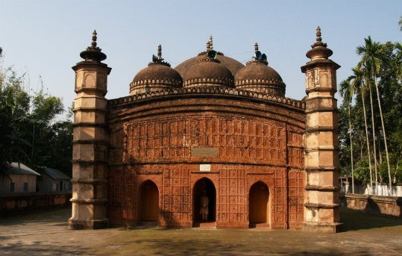
- The Shah Hamadan mosque, J & K
- Atiya mosque, Mymensingh, Bangladesh
- Muchundi Mosque, Kozhikode
- Humayun’s Tomb, Delhi
Ans. B
- This mosque is situated on the right bank of the river Jhelum between the Fateh Kadal and Zaina Kadal bridges. It was first built in 1395 CE, commissioned by Sultan Sikandar Shah. it is one of the best examples of Kashmiri wooden architecture which is decorated with papier mache. Identify.
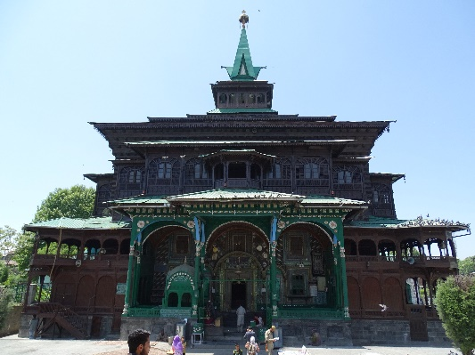
- Atiya mosque
- Muchundi Mosque
- The Moi-e-Muqqadas
- The Shah Hamadan mosque
Ans. D
- He was the disciple of Nizamuddin Auliya and popularly known as Parrot of India. Identify him.
- Abul Fazl
- Muinuddin Chisthi
- Akbar
- Amir Khusrau
Ans. D
- It was a famous painting of Manohar where the Shaikhs greeting the Mughal emperor on his pilgrimage to Ajmer. Identify the Mughal Emperor.
- Jahangir
- Akbar
- Aurengzeb
- Shah Jahan
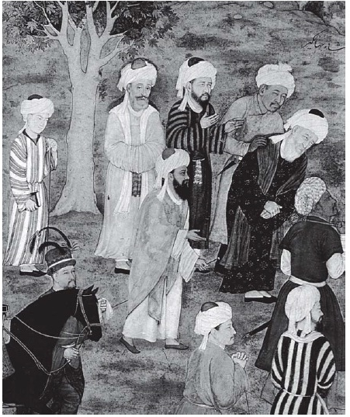
Ans. A
- The dargah is the burial place of a famous Sufi saint constructed in Fatehpur Sikri. This tomb is known for Child Birth Blessing. Identify the Sufi Saint.
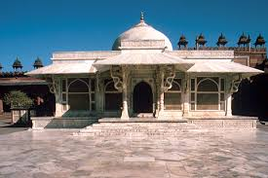
- Nizamuddin Auliya
- Shaikh Salim Chishti
- Baba Farid
- Muinuddin Chisthi
Ans. B
- A fifteenth-century stone sculpture from Tamil Nadu. Identify the deity.
- Murugan
- Virupaksha
- Krishna
- Vithal
Ans. C
**********

